**Title Page**

**Aristide** – a Conference Management System



**Bharati Vidyapeeth’s College of Engineering** (New Delhi)

A-4, Paschim Vihar, Rohtak Road, New Delhi, 110027

B. Tech

In

Computer Science Engineering

Under the Supervision of

**Dr. Mohit Tiwari**

By

**Anant Tyagi, Aditya Dev Sharma, Kshitij Kaushik, Priyansh Singh & Divyanshu Sharma**

To

Bharati Vidyapeeth’s College of Engineering

Guru Gobind Singh Indraprashtha University

Dwarka, New Delhi

April 2015

**Certificate**

This is to certify that Report entitled “*Aristide – CMS”* which is submitted by Anant Tyagi, Aditya Dev Sharma, Kshitij Kaushik, Priyansh Singh and Divyanshu Sharma in partial fulfillment of the requirement for the award of degree B.Tech in 2016 to Bharati Vidyapeeth’s College of Engineering affiliated to GGSIPU, is a record of the candidate own work carried by him/her under my/our supervision. The matter embodied in this report is original and has not been submitted for the award of any other degree.

**Date: Supervisor**

**Acknowledgement**

This project required great amount of efforts, time and dedication of each individual group member. However, its implementation would not have been completed without the kind support of many individuals and organizations. Therefore, we would like to extend our sincerest gratitude to all of them.

We are highly indebted to **Mr. Mohit Tiwari**, our project guide, for his guidance and constant supervision as well as for providing necessary information throughout the course of the project.

We would also like to express our gratitude towards the different **faculty members** of **Bharati Vidyapeeth’s College of Engineering** who reviewed our project at different stages and helped us to improve constantly through their invaluably constructive criticism and friendly advice.

We would also like to express our thanks towards the different **faculty members** of **Bharati Vidyapeeth’s College of Computers Application and Management** who provided invaluable insight in the incipient stages of the project.

Nevertheless, we are thankful to our families and classmates for their kind co-operation, encouragement and useful insights which helped us in the completion of this project.

**TABLE OF CONTENTS**

**1. Acknowledgement……………………………………………………………………………………….3**

**2. Abstract……………………………………………………………………………………………………….5**

**3. Introduction**

3.1 Scope……………………………………………………………………………………………...6

3.2 Existing System……………………………………………………....6

3.3 Objectives of Conference Management System…………………...…7

3.4 Salient features of the Conference Management System………….....7

3.5 Definitions, acronyms and abbreviations……………………………..8

**4. Overall Description**

4.1 Product Perspective ……………………………………………………………………………....8

4.1.1 System interfaces…………………………………………………………………………8

4.1.2 User interfaces……………………………………………………………………………..8

4.1.3 Hardware interfaces……………………………………………………………………..9

4.1.4 Software interfaces……………………………………………………………………….9

4.1.5 Communication interfaces…………………………………………………………….9

4.1.6 Memory interfaces………………………………………………………………………..9

4.2 User characteristics…………………………………………………………9

**5.** **SCREENS AND INTERFACES**……………………………………………………………………………….10

5.1 SCREENSHOTS OF SOME INTERFACES OF DIFFERENT MODULE…………………………..10

**6.** **SOFTWARES USED………………………………………………………………………………………...11**

6.1 XAMPP……………………………………………………………………………………………….......11

6.2 MYSQL……………………………………………………………………………………………..………11

6.3 MATLAB……………………………………………………………………………………………………12

**7. PROGRAMMING LANGUAGE USED……………………………………………………............12**

**8.** **ADVANTAGES**……………………………………………………………………13

**9.** **BIBLIOGRAPHY**…………………………………………………………………………………………………15

**Abstract**

The purpose of the website is to provide a user-friendly interface that is not only easy to navigate, but at the same time provides in depth and sufficient information about various conferences and journals.

Two potential groups of users exist:

* Budding researchers, who want to view or write research based papers.
* Veteran researchers, who will be reviewing and verifying the papers to be published according to their respective fields of expertise.

The website access will be authenticated, and the site provides a secure environment for all users.

Benefits of using the site include:

* An easy to use and effective portal for paper submission, review and registration process for conferences, workshops and journals
* It is a hosted and supported service, i.e., there is no software to install and support staff can help authors, reviewers and chairs with any problems. Users interact with the site using standard web browsers.
* Email notifications to members, reviewers and authors
* Conference specific submission system

Major features of the website include the following subsections:

* **Registration and payment.**Our conference registration module handles the creation of the registration forms, the collection of online payments (where required), and email communications with the delegates. Although the system keeps track of all transactions, payments are collected directly into the organisers' merchant account. COMS has no access to the funds or bank details of the delegates.
* **Abstract submission**  
  Organisers can configure the submission form to include any number of items. A simple text editor or, alternatively, a rich editor allowing styling and the inclusion of tables and pictures can be used to collect abstract texts. Extended abstracts and full-papers can be uploaded in any specified format.
* **Reviews**  
  Organisers can configure up to nine numerical criteria for the evaluation of submissions by the reviewers. Textual appraisals and feedback for the submitters can also be collected. They can use blind reviews. Assigning the reviews to referees can be done manually by the Chair. Reviewers can perform the reviews online from their account. Organisers can track their progress and send them reminders by email.
* **Abstract selection**Abstract selection can be performed automatically or manually. The automatic option selects submissions on the value of the marks given by the reviewers and can be followed by a manual selection. Accepted abstracts can be assigned to **sessions and ordered.**
* **Participant selection**  
  Participants can be selected independently of the abstract selection process. Alternatively, their selection can be synchronised with the selection of abstracts.
* **Emails**

The email module can be configured to send automatic emails, bulk emails and email alerts to organisers. Filters are supplied to allow the targeting of groups of users when sending bulk emails. Prefilled templates are supplied for the bulk and automatic mails. These can be edited and personalised by means of placeholders.

Book of abstracts  
Submitted abstracts can be styled and exported to HTML or PDF. Uploaded files, as well as the PDF files generated from the submissions can be downloaded from the FTP server.

## 3. INTRODUCTION

## 3.1 Scope

The Conference Management System is being developed for BVCOE to replace old paper work system. The system is to build upon the existing web-based project marking system in order to implement the conference management process and allocating supervisor/ideas to students. This increase in efficiency of data access, Conference management, gives feedback to student, finally, publication of documents. It provides a mechanism to organize any conference online which makes the system is flexible.

**3.2 Existing system**

**N**owadays, there are many types of department System which have many features and facilities regarding to the access of information related to departments. With emergence of new and cost effective System websites, traditional methods for information access and service delivery are either becoming obsolete or it has become necessary to augment these methods with the new modern tools. Different websites have different look and feel, presentation style, structure, and color schema  as these follow different technology standards, design lay-outs and navigation architecture etc. It results in lot of inconvenience to the user and requires a lot of learning on their part to access the information and services. On the other hand it is challenging job for the owners of these websites also to keep all the information updated and in sync at multiple websites all the time. This results in duplicate efforts, outdated content, multiple sources of information, mismatch of the information finally confusing the service consumer.

## 3.3 Objectives of Conference Management System

The major objectives of the Conference Management System are as follows:-

* To provide one stop, single window solution to all the students for accessing information and services related to the department eliminating the need to remember multiple URL and to navigate multiple web sites and applications.
* To act as a gateway for delivery of information and services in department which will be accessed using Conference Management System.
* To complement and enhance service delivery channels which may already exist at the university level.
* To build a comprehensive knowledge management system for university students by providing platform to collaborate and share knowledge.
* To act as a bridge between students and the department faculty  at the highest decision making level by simplifying their interactions with department entities reducing service cycle time and providing enriching experience.
* To provide a secure and individualized view and interactive services.

## 3.4 Salient features of Conference Management System

The salient features of Conference Management System are as follows:-

* Use of icons/pictures/ images and graphical interfaces to represent links and information for quicker understanding of the students.
* Consistent and Easy to Use interface- Consistent design of the web pages for common look and feel.
* Easy to navigate, search and browse- Site map for navigation guidance.
* Interface for the updation of information and service delivery for departments.
* Well designed home page conveying theme and purpose.
* Single Sign-on to access all information and services on the System.
* Self service- Interface to user to set/reset his/her own password. The System should allow the user to fulfill his needs, wherever possible, through self-service.
* Discussion Boards - to allow all kinds of users to interact with each other with provision of discussion.
* Feedback and Analysis mechanism – for constant improvement and enrichment of the System for user satisfaction.

## 

## 3.5 Definitions, acronyms, and abbreviations

|  |  |
| --- | --- |
| IEEE | The Institute of Electrical and Electronics Engineers, Inc. |
| OPMS | Online Project Marking System |
| PUMS | Project Units Management System |
| SRS | Software Requirements Specification |
| J2EE | Java 2 Platform Enterprise Edition |
| JSP | Java Server Page |
| OS | Operating System |
| HTML | Hyper Text Mark-up Language |
| PHP | Hypertext Pre-processor |
| CMS | Content Management System |
| CMP | Conference Management System |

## 4. Conference Management System - Overall description

## 4.1 Product perspective

The Conference Management System (CMP) would be composed of presentation, application, data access and security layers which would provide the platform to house the applications suggested for use at the department level. All the service requests with respect to these applications initiated using different delivery channels would be processed by the Conference Management System. These Systems and existing applications will share data using web services.

### 4.1.1 System interfaces

The System uses packages that can either connecting to an Oracle database or MySQL database through the Database Utility components. The possible extension is to inter-connection to UP Link System which provide student with many functions, including the ability to check assessment results. Students can connect both systems to retrieve information on their academic progress.

### 4.1.2 User interfaces

All pages of the system are following a consistent theme and clear structure. The occurrence of errors should be minimized through the use of checkboxes, radio buttons and scroll down in order to reduce the amount of text input from user. JavaScript implement in HTML in order to provide a Data Check before submission.  HTML Tables to display information to give a clear structure that easy to understand by user. Error message should be located beside the error input which clearly highlight and tell user how to solve it. If system error, it should provide the contact methods. The page should display the project process in different colour to clearly reflect the various states that student done. Each level of user will have its own interface and privilege to manage and modify the project information such as supervisor able to monitor/manage his student progress and make comment on it, student can change his detail, view the progress, submit project idea. The System should provide a feedback form for all users to give comments or asking questions. It should provide a FAQ to minimize the workload of system administrator.

### 4.1.3 Hardware interfaces

Users of the Conference Management System will be able to access Conference Management System on their client systems, smart phones. To host the System, hardware servers will be required for System server (Content Management), Application Server, Database, Mail server with adequate back up facilities and disaster recovery mechanism for 24 X 7 availability.

### 4.1.4 Software interfaces

User will be able to access the System using web browser on the system having base Operating System. On Server end, in addition to base Operating system, software will be required for internet server, Content Management, Database, LDAP directory services, application frameworks, email server etc.

### 4.1.5 Communications interfaces

The HTTP protocol will be used to facilitate communications between the client and server.

## 4.2 User Characteristic

Target user groups for the CMP can be broadly classified under five main categories, these are:

* **Administrato**r – Users who have all the privileges regarding the Conference Management System. He/she have all the permissions and authorization to every conferences.
* **Author** – Users who feeds all the papers and documents regarding the conferences.
* **Reviewer** – Users who publishes all the papers and documents online, created by authors.
* **Conference Administrator** – Users who have access and authorization relevant only to a particular conference. He/she don’t have any permissions of other conferences.
* **Anonymous Users** – Users who anonymously just visit the website to read about the System.

**5. SCREENS AND INTERFACES**

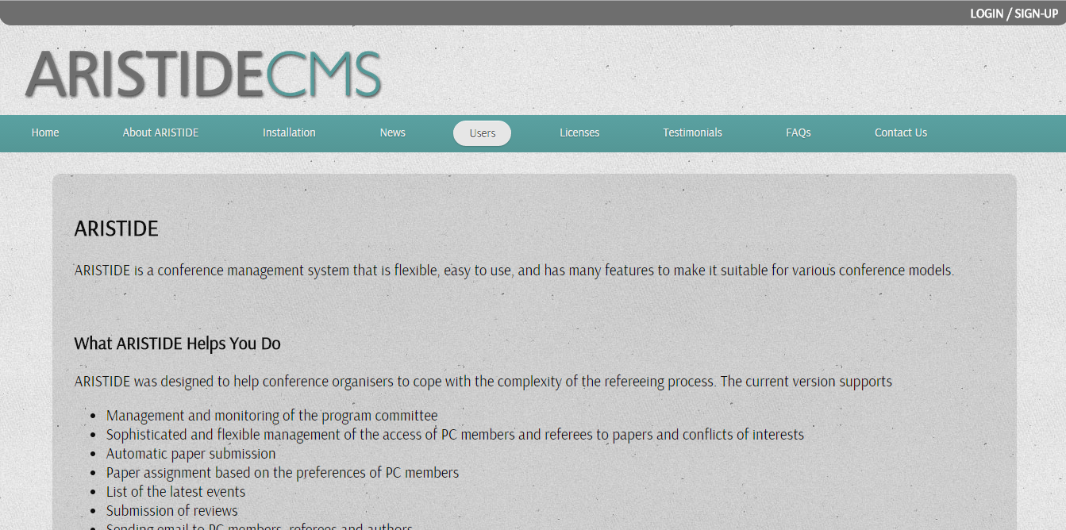

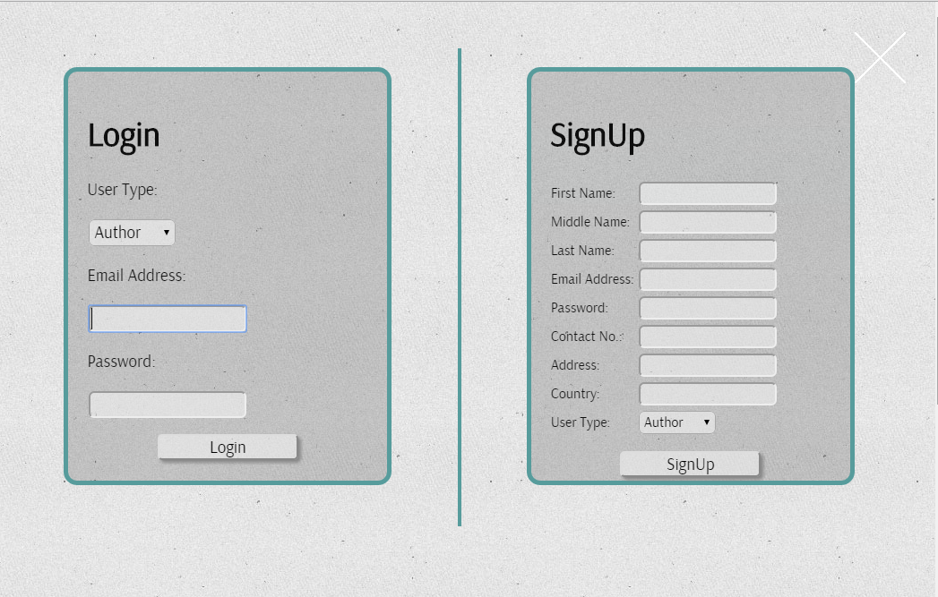

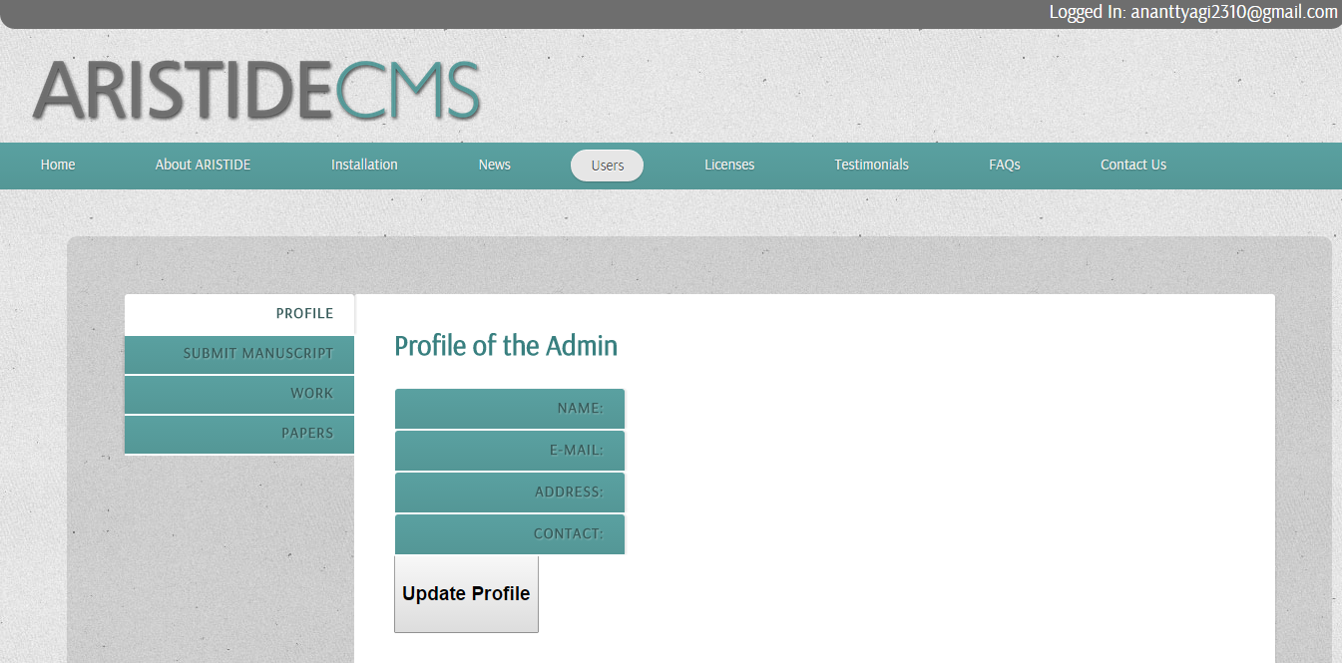

**6. SOFTWARES USED**

**6.1 XAMPP**

**XAMPP** is a free and open source cross-platform web server solution stack package, consisting mainly of the Apache HTTP Server, MySQL database, and interpreters for scripts written in the PHP and Perl programming languages. XAMPP also provides support for creating and manipulating databases in MySQL and SQLite among others.Once XAMPP is installed, it is possible to treat a localhost like a remote host by connecting using an FTP client. Using a program like FileZilla has many advantages when installing a content management system (CMS) like Joomla or WordPress. It is also possible to connect to localhost via FTP with an HTML editor.The default FTP user is "newuser", the default FTP password is "wampp". The default MySQL user is "root" while there is no default MySQL password.

**6.2 MySQL**

**MySQL**,is the world's second most widely used relational database management system (RDBMS) and most widely used open-source RDBMS. The MySQL development project has made its source code available under the terms of the GNU General Public License, as well as under a variety of proprietary agreements. MySQL was owned and sponsored by a single for-profit firm, the Swedish company MySQL AB, now owned by Oracle Corporation. MySQL is a popular choice of database for use in web applications, and is a central component of the widely used LAMP open source web application software stack (and other 'AMP' stacks). LAMP is an acronym for "Linux, Apache, MySQL,Perl/PHP/Python." Free-software-open source projects that require a full-featured database management system often use MySQL.

**6.3 MATLAB**

**MATLAB** (**mat**rix **lab**oratory) is a multi-paradigm numerical computing environment and fourth-generation programming language. Developed by MathWorks, MATLAB allows matrix manipulations, plotting of functions and data, implementation of algorithms, creation of user interfaces, and interfacing with programs written in other languages, including C, C++, Java,Fortran and Python.Although MATLAB is intended primarily for numerical computing, an optional toolbox uses the MuPAD symbolic engine, allowing access to symbolic computing capabilities. An additional package, Simulink, adds graphical multi-domain simulation and Model-Based Design for dynamic and embedded systems.

**7. PROGRAMMING LANGUAGE USED**

**PHP**

PHP is required for CMS, however for the CMS Toolkit, PHP must be complied with support for URL, DomDocument, and SimpleXML. Such functionality is necessary for making external HTTP requests to OAI and NCIP servers and handling XML responses.  While PHP originally stood for *Personal Home Page* it now stands for *PHP: Hypertext Preprocessor*, which is a [recursive](http://en.wikipedia.org/wiki/Recursive_acronym) [backronym](http://en.wikipedia.org/wiki/Backronym). PHP code can be simply mixed with [HTML](http://en.wikipedia.org/wiki/HTML) code, or it can be used in combination with various [templating engines](http://en.wikipedia.org/wiki/Web_template_system) and [web frameworks](http://en.wikipedia.org/wiki/Web_framework). PHP code is usually processed by a PHP [interpreter](http://en.wikipedia.org/wiki/Interpreter_(computing)), which is usually implemented as a web server's native [module](http://en.wikipedia.org/wiki/Plugin_(computing)) or a [Common Gateway Interface](http://en.wikipedia.org/wiki/Common_Gateway_Interface) (CGI) executable. After the PHP code is interpreted and executed, the web server sends resulting output to its client, usually in form of a part of the generated web page; for example, PHP code can generate a web page's HTML code, an image, or some other data. PHP has also evolved to include a [command-line interface](http://en.wikipedia.org/wiki/Command-line_interface) (CLI) capability and can be used in[standalone](http://en.wikipedia.org/wiki/Computer_software) [graphical applications](http://en.wikipedia.org/wiki/Graphical_user_interface).

**ADVANTAGES**

**High Availability**

High availability refers to a system or component that is continuously operational for a desirably long length of time. It is an  ability to withstand failure of  individual components.  Conference Management System should be highly available. To make CMP to be highly available, it is essential that all components like hardware, network, system software, and application software are operational all the time.  If the system is not available for all the time, user loses his interest and avoids using the service again presuming that it may waste user’s time  in accessing the service without any result.

**Scalability**

Scalability is the ability of a system, network, or process, to handle growing amount of load  in a CMPable manner by means of deploying additional resources, if required, without any noticeable degradation of its performance. Conference Management System should be able to cope up with significant increase in load or page requests, without noticeable degradation in performance, by means of deploying additional hardware but without making any changes in the application software.  Scalability should be addressed at each and every component level.

**Reliability**

Software Reliability is an important to attribute of software quality.  Reliability is the probability of failure-free software operation for a specified period of time in a specified environment. Due to any human interventions, the system should not behave abnormally. Software failures may be due to errors, ambiguities, oversights or misinterpretation of the specification that the software is supposed to satisfy, carelessness or incompetence in writing code, inadequate testing, incorrect or unexpected usage of the software or other unforeseen problems. It is expected that there shall not be any bug while operating .Conference Management System and the system shall be tested on end cases to offer user a quality and reliable package.

**Usability**

Usability is a quality attribute that assesses how easy user interfaces are to use. Compromising user friendliness leads to loss of productivity. Conference Management System should be easy to use. The underlying technology should be transparent to users, so they can concentrate on tasks at hand. Screens should be designed for ease of use by non-technical users who do not have any computer knowledge. The GUI design shall be intuitive and task-based without any superfluous design.

Usability is defined by 5 quality components:-

* Learnability: How easy is it for users to accomplish basic tasks the first time they encounter the design?
* Efficiency: Once users have learned the design, how quickly can they perform tasks?
* Memorability: When users return to the design after a period of not using it, how easily can they restablish proficiency?
* Errors: How many errors do users make, how severe are these errors, and how easily can they recover from the errors?
* Satisfaction: How pleasant is it to use the design?

**Extensibility**

Extensibility refers the ability to add new functionality without requiring major changes to the existing code. Conference Management System should be extensible in the sense that new features can be easily added or plugged-in without any  significant changes to the existing system.

**Maintability**

Software maintenance is the modification of a software product after delivery to correct faults, to improve performance or other attributes.

As per ISO/IEC 14764 Maintenance activities can be categorized as :-

* Corrective maintenance: Reactive modification of a software product performed after delivery to correct discovered problems.
* Adaptive maintenance: Modification of a software product performed after delivery to keep a software product usable in a changed or changing environment.
* Perfective maintenance: Modification of a software product after delivery to improve performance or maintainability.
* Preventive maintenance: Modification of a software product after delivery to detect and correct latent faults in the software product before these become effective faults.

Maintainability is defined as the ease with which a software system or component can be modified to correct faults, improve performance or other attributes, or adapt to a changed environment.

**Security**

The services of conferences which will be accessible from Conference Management System have been categorized as information services, transaction services and workflow services. Most of the information for information services will be in public domain. Security requirements of the transaction based services and workflow based services are high. Adequate safety measures would be incorporated during development stage itself to prevent vulnerabilities and build secured code for these services on Conference Management System. The system should have protection against unauthorized creation / modification of data and unauthorized viewing of data

**9. BIBLIOGRAPHY**

[1] http://www.conference-service.com/index.html

[2] http://www.american.edu/cas/economics/info-metrics/pdf/upload/zellner- bayesian-analysis.pdf

[3] https://www.apachefriends.org/index.html

[4] https://www.thenewboston.com/videos.php?cat=11